Project Powerlift Final Analysis:

Powerlifting is the sport of lifting heavy weights in three different ways from a standing or lying position, but without lifting the weights above the head.

It consists of three lifts: the squat, the bench press and deadlift. In this project, our goal is to obtain a large database, and clean the data to find relationships.

In doing so, we are seeking to answer the following questions:

- Does age have a correlation with performance in powerlifting competitions? Our initial thoughts would be that younger athletes would have a higher likeliness of succeeding in

competition, but the data may suggest otherwise. Is it possible that adults in their 30s and 40s could begin taking training more seriously, and getting ready

for competitions more effectively? Is there a prime age? and could this prime age be different between genders?

- This leads to our next question of a relationship between genders in powerlifting competitions. In this project, we are looking to answer questions about how each gender performs across

different age and weight ranges. One question we had early was related to the disparities in participation of certain weight classes between both genders, and whether this may impact the

results when looking for correlation. Also, are there similar results between men and women of similar weight? and does this change at different age ranges?

- Lastly, we want to understand the relationship of body weight with powerlifting. On the surface we would hypothesize that bigger lifters would be able to lift more weight, but does this

theory hold truth when we look at the data? It's worth asking, does body weight correlated to overall strength, and if so, at which weight range does that advantage start to taper?

Does having more weight carry the same effectiveness across both genders? and at all age ranges? Cleaning the data to show relationships of weight over different ages and amongst both

genders competing could show contrary results to original beliefs.

Results:

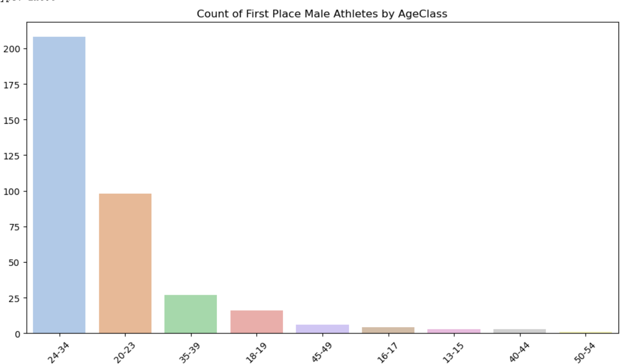

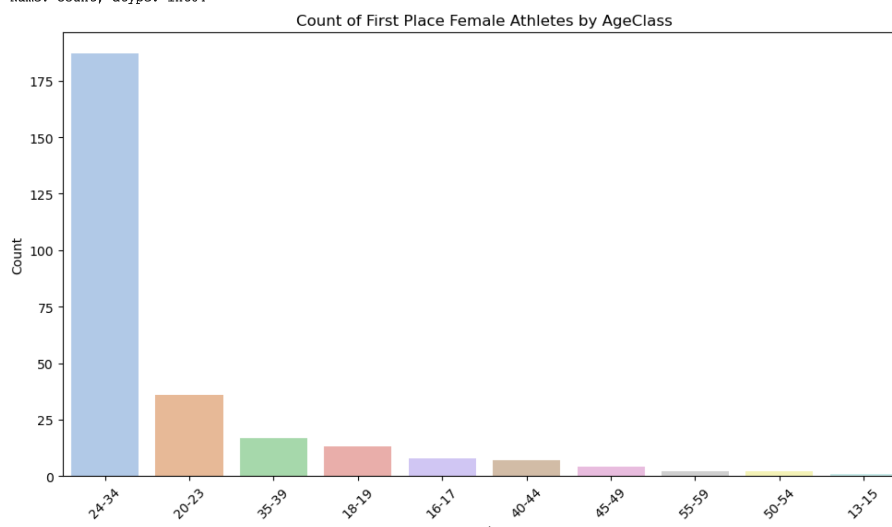

For this task, we used the data to find all winners of competitions, and sorted those winners into age ranges. The results show what one may expect, as 208 of the 355 winners for men, and 187 of the 261 women were in the youngest age range, and the total descended as the age group increased, showing some proof to our original hypothesis

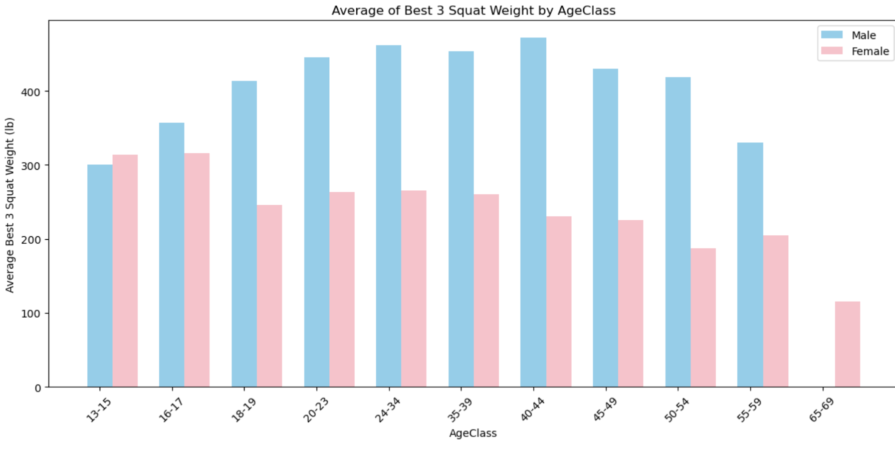

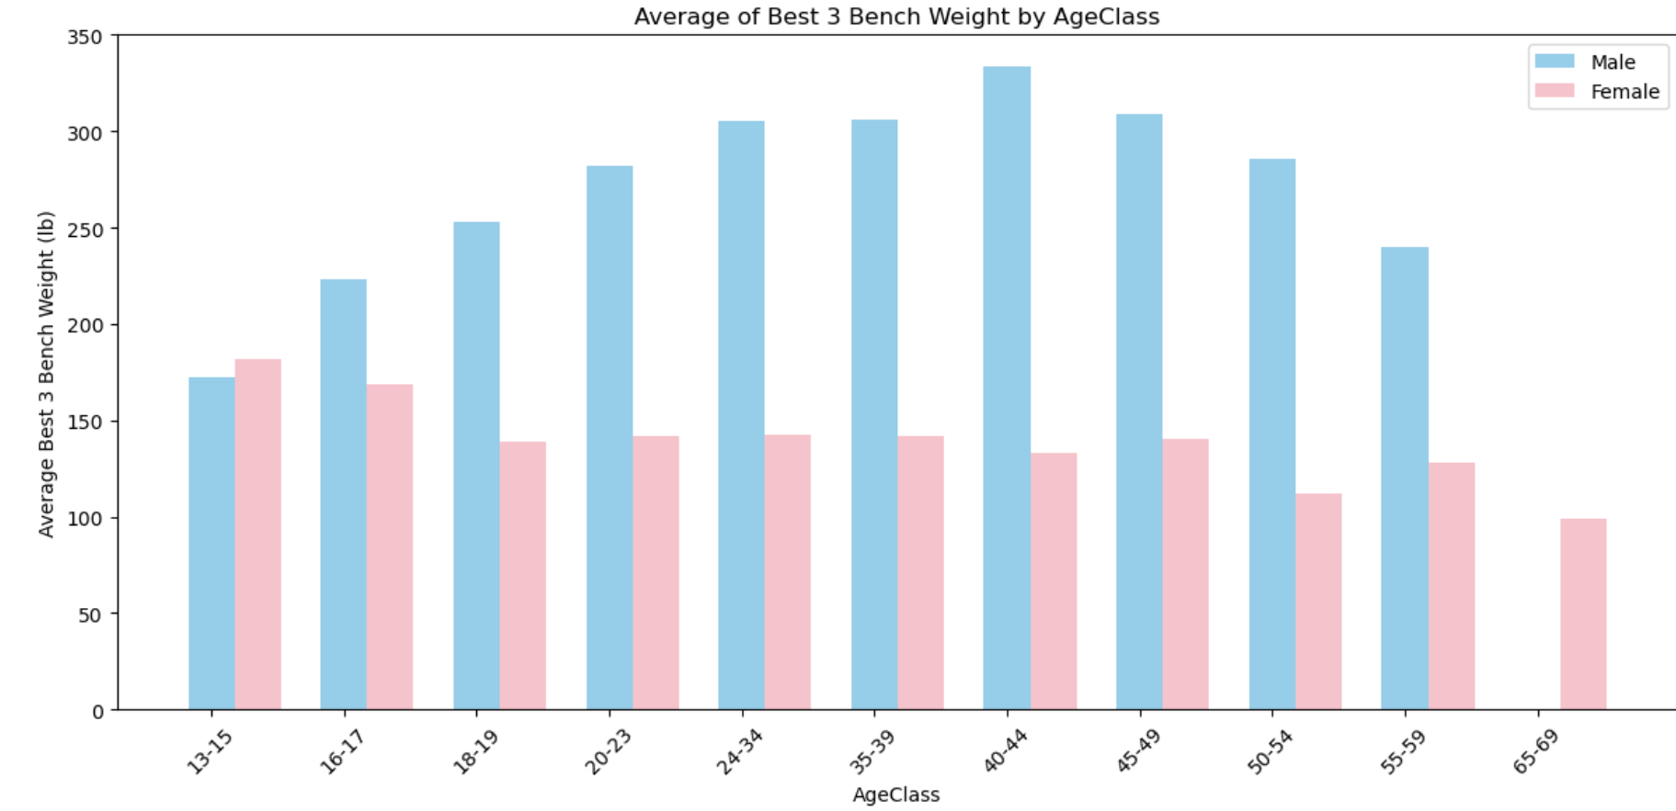

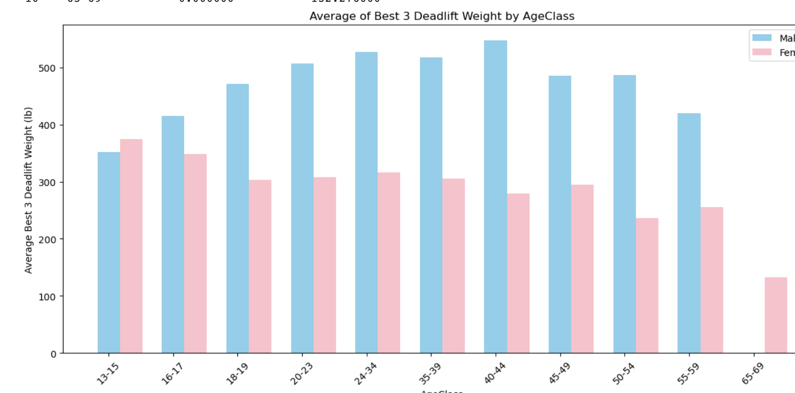

Here, we look at the best 3 results for each of the three lifts, across both genders. What’s interesting here is that the female competitors appear to outlift males both early, and later in life, but in the years 16-59, males are outlifting by a fair amount. There’s many reasons we may be seeing this, as it may show signs that females develop earlier than males, and may have higher longevity in later years, but overall on average for almost all age ranges, male’s lift the most weight.

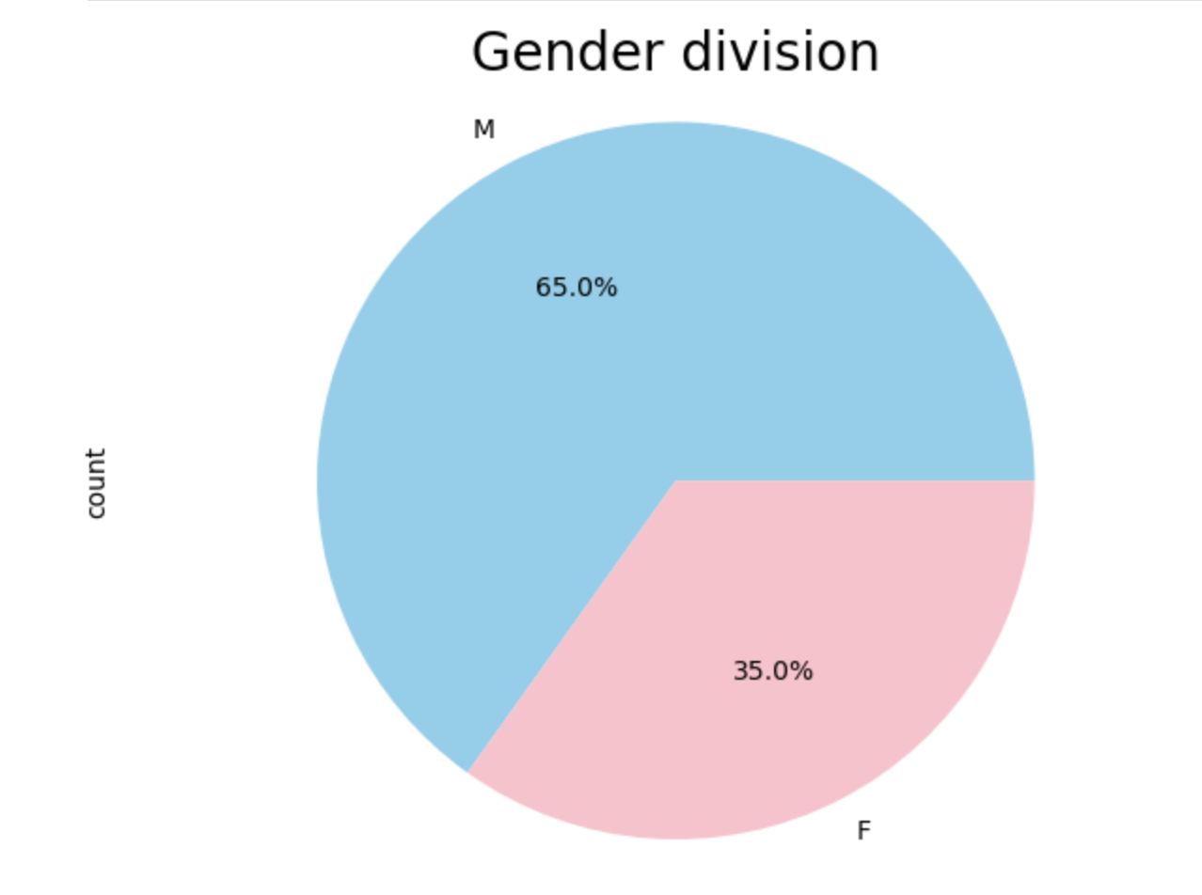

It’s important to know the sample size we are working with in the data. For this dataset, a majority of competitors are male (65%). Because of the smaller sample size of females, it’s important to note disparities in certain areas, such as female representation in higher weight classes, or in certain age ranges.

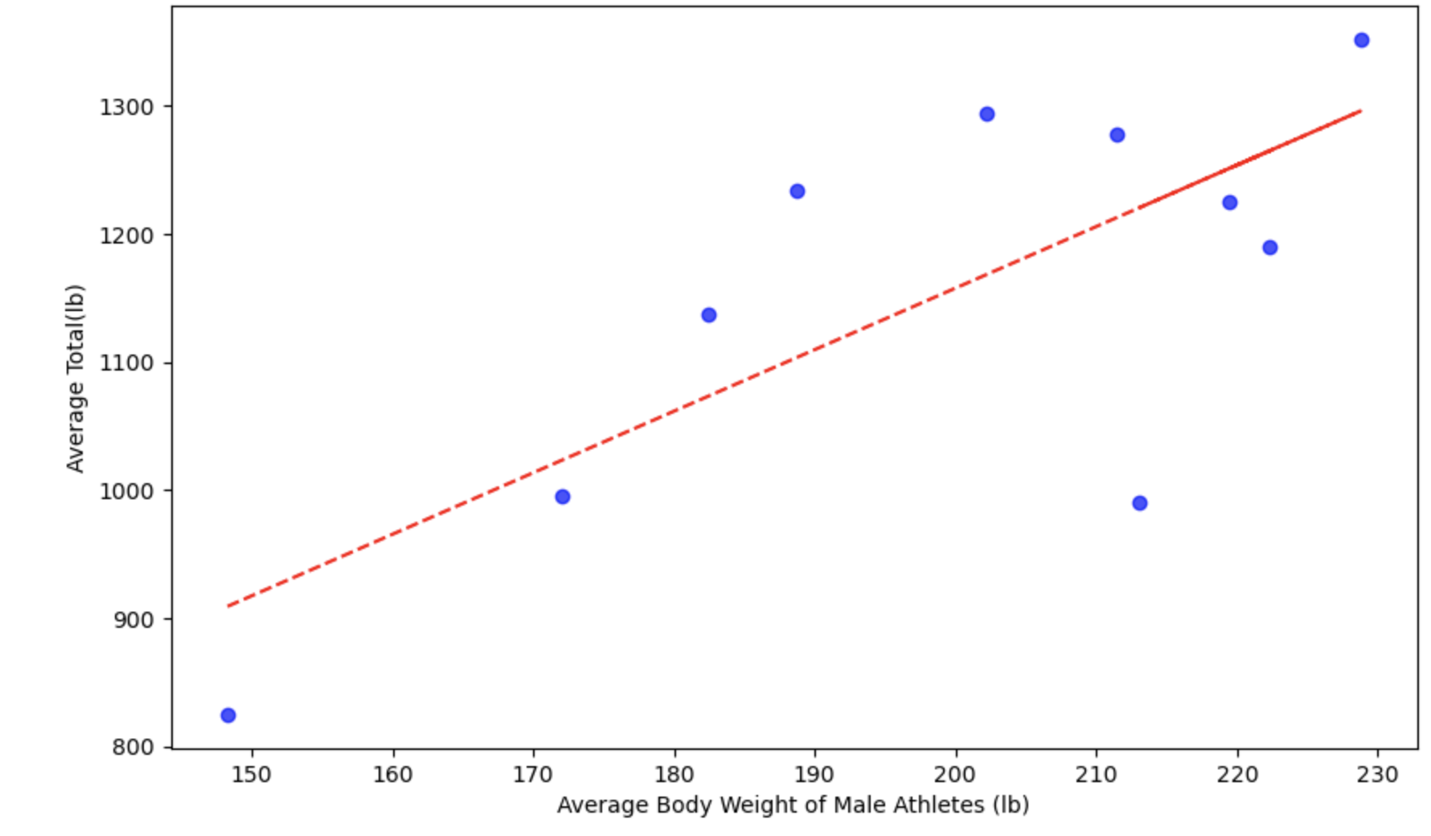

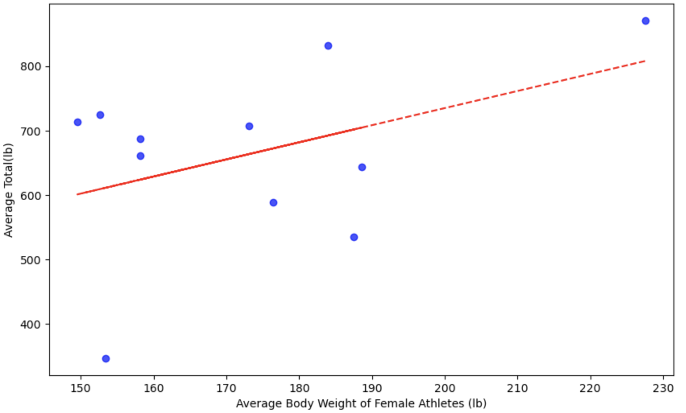

The last results we wanted to look deeper into was how bodyweight effects lifting. Our original hypothesis states that a higher body weight would correlate with being able to lift more weight. To test this, we took the total weight lifted between deadlift, bench press, and squat, and measured the average totals across all weight ranges that competed. Regardless of gender, there appears to be a correlation between weight and amount lifted. The results seem stronger for males, but this may be due to the lack of women in the sample size above 200Ib, so there’s less data to support that claim. But nonetheless, it appears to hold true as the highest weight, on average appears to lift the most total weight in competition.